Staff Management

**Developed by**

**Engineer Vladislav Zhivkov**

**Contents**

Assignment Conditions 2

Models 3

• Logical 3

• Relational 4

Tables Creation 5

Tables Relations 1

Adding data to the Tables 1

*Information for the employees* 1

*Absence Types* 0

*Number of absences/attendances* 0

*Departments* 1

*ID absences* 1

*Number of Languages* 1

*Languages* 0

*Months* 1

*Positions* 1

*Calendar* 1

Requests and their executions 1

Procedures 5

Triggers 10

Cursors 13

# Assignment Conditions

To design and implement a database for PERSONNEL MANAGEMENT in a company to store the following information:

* Worker/employee - name, surname, position, department, salary, date of entry, languages ​​spoken
* Attendance, absence due to illness/vacation in several days for each month per employee

Rules:

* Each employee can be assigned to only one department
* All employees may have only one job title

The database must be normalized and allow:

1. Input, corrections, deletion of data.
2. Search for:

* employee by last name, position, department
* employees in languages ​​he speaks

1. References to:

* The last 5 appointed employees, sorted by date of appointment
* Employees, for position/department
* Appointed employees for a period
* Number of absences for each employee per year

# Models

## Logical

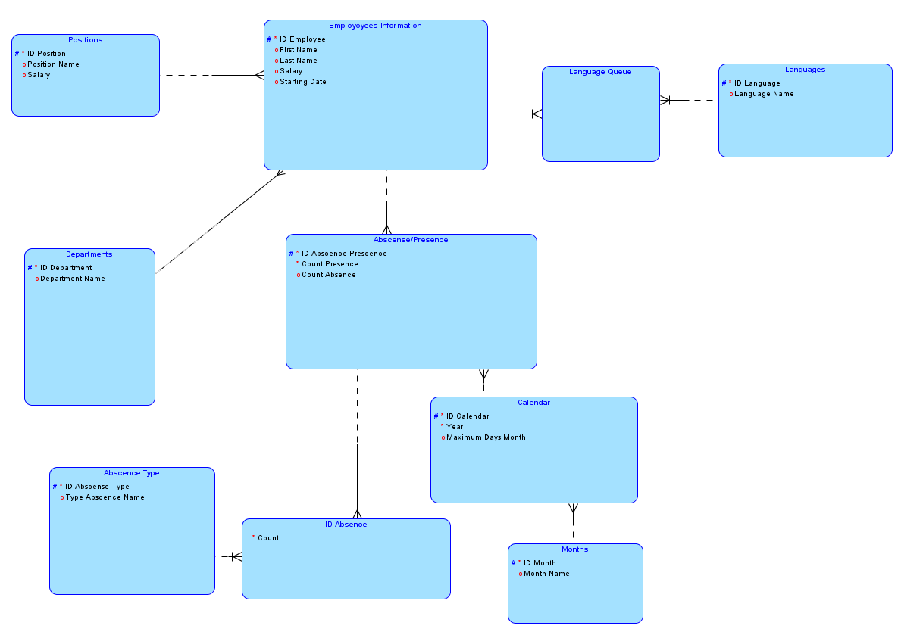

## Relational

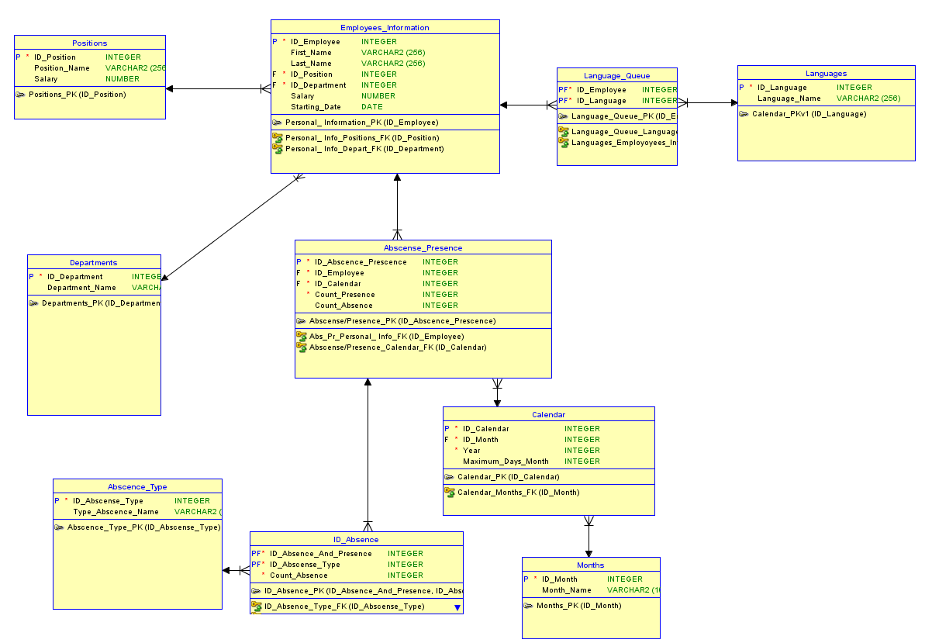

# Tables Creation

**CREATE TABLE abscence_type (**

**id_abscense_type INTEGER NOT NULL,**

**type_abscence_name VARCHAR2(10)**

**);**

**ALTER TABLE abscence_type ADD CONSTRAINT abscence_type_pk PRIMARY KEY ( id_abscense_type );**

**CREATE TABLE abscense_presence (**

**id_abscence_prescence INTEGER NOT NULL,**

**id_employee INTEGER NOT NULL,**

**id_calendar INTEGER NOT NULL,**

**count_presence INTEGER NOT NULL,**

**count_absence INTEGER**

**);**

**ALTER TABLE abscense_presence ADD CONSTRAINT "Abscense/Presence_PK" PRIMARY KEY ( id_abscence_prescence );**

**CREATE TABLE calendar (**

**id_calendar INTEGER NOT NULL,**

**id_month INTEGER NOT NULL,**

**year INTEGER NOT NULL,**

**maximum_days_month INTEGER**

**);**

**ALTER TABLE calendar ADD CONSTRAINT calendar_pk PRIMARY KEY ( id_calendar );**

**CREATE TABLE departments (**

**id_department INTEGER NOT NULL,**

**department_name VARCHAR2(256)**

**);**

**ALTER TABLE departments ADD CONSTRAINT departments_pk PRIMARY KEY ( id_department );**

**CREATE TABLE employees_information (**

**id_employee INTEGER NOT NULL,**

**first_name VARCHAR2(256),**

**last_name VARCHAR2(256),**

**id_position INTEGER NOT NULL,**

**id_department INTEGER NOT NULL,**

**salary NUMBER,**

**starting_date DATE**

**);**

**ALTER TABLE employees_information ADD CONSTRAINT "Personal_ Information_PK" PRIMARY KEY ( id_employee );**

**CREATE TABLE id_absence (**

**id_absence_and_presence INTEGER NOT NULL,**

**id_abscense_type INTEGER NOT NULL,**

**count_absence INTEGER NOT NULL**

**);**

**ALTER TABLE id_absence ADD CONSTRAINT id_absence_pk PRIMARY KEY ( id_absence_and_presence,**

**id_abscense_type );**

**CREATE TABLE language_queue (**

**id_employee INTEGER NOT NULL,**

**id_language INTEGER NOT NULL**

**);**

**ALTER TABLE language_queue ADD CONSTRAINT language_queue_pk PRIMARY KEY ( id_employee,**

**id_language );**

**CREATE TABLE languages (**

**id_language INTEGER NOT NULL,**

**language_name VARCHAR2(256)**

**);**

**ALTER TABLE languages ADD CONSTRAINT calendar_pkv1 PRIMARY KEY ( id_language );**

**CREATE TABLE months (**

**id_month INTEGER NOT NULL,**

**month_name VARCHAR2(10));**

**ALTER TABLE months ADD CONSTRAINT months_pk PRIMARY KEY ( id_month );**

**CREATE TABLE positions (**

**id_position INTEGER NOT NULL,**

**position_name VARCHAR2(256),**

**salary NUMBER**

**);**

**ALTER TABLE positions ADD CONSTRAINT positions_pk PRIMARY KEY ( id_position );**

# Tables Relations

**ALTER TABLE abscense_presence**

**ADD CONSTRAINT "Abs_Pr_Personal_ Info_FK" FOREIGN KEY ( id_employee )**

**REFERENCES employees_information ( id_employee );**

**ALTER TABLE abscense_presence**

**ADD CONSTRAINT "Abscense/Presence_Calendar_FK" FOREIGN KEY ( id_calendar )**

**REFERENCES calendar ( id_calendar );**

**ALTER TABLE calendar**

**ADD CONSTRAINT calendar_months_fk FOREIGN KEY ( id_month )**

**REFERENCES months ( id_month );**

**ALTER TABLE id_absence**

**ADD CONSTRAINT id_absence_type_fk FOREIGN KEY ( id_abscense_type )**

**REFERENCES abscence_type ( id_abscense_type );**

**ALTER TABLE id_absence**

**ADD CONSTRAINT "ID_Absence/Prescense_FK" FOREIGN KEY ( id_absence_and_presence )**

**REFERENCES abscense_presence ( id_abscence_prescence );**

**ALTER TABLE language_queue**

**ADD CONSTRAINT language_queue_languages_fk FOREIGN KEY ( id_language )**

**REFERENCES languages ( id_language );**

**ALTER TABLE language_queue**

**ADD CONSTRAINT languages_employoyees_info_fk FOREIGN KEY ( id_employee )**

**REFERENCES employees_information ( id_employee );**

**ALTER TABLE employees_information**

**ADD CONSTRAINT "Personal_ Info_Depart_FK" FOREIGN KEY ( id_department )**

**REFERENCES departments ( id_department );**

**ALTER TABLE employees_information**

**ADD CONSTRAINT "Personal_ Info_Positions_FK" FOREIGN KEY ( id_position )**

**REFERENCES positions ( id_position );**

# Adding data to the Tables

## *Information for the employees*

Insert into EMPLOYEES_INFORMATION (ID_EMPLOYEE,FIRST_NAME,LAST_NAME,ID_POSITION,ID_DEPARTMENT,SALARY,STARTING_DATE)

values (10,'Pesho','Ivanov',0,103,3127.71,to_date('2013-03-27','RRRR-MM-DD'));

Insert into EMPLOYEES_INFORMATION (ID_EMPLOYEE,FIRST_NAME,LAST_NAME,ID_POSITION,ID_DEPARTMENT,SALARY,STARTING_DATE)

values (11,'Ivan','Petkov',1,103,1992.09,to_date('2013-06-05','RRRR-MM-DD'));

Insert into EMPLOYEES_INFORMATION (ID_EMPLOYEE,FIRST_NAME,LAST_NAME,ID_POSITION,ID_DEPARTMENT,SALARY,STARTING_DATE)

values (12,'Cvetelina','Gerganova',2,100,1052.27,to_date('2013-08-30','RRRR-MM-DD'));

Insert into EMPLOYEES_INFORMATION (ID_EMPLOYEE,FIRST_NAME,LAST_NAME,ID_POSITION,ID_DEPARTMENT,SALARY,STARTING_DATE)

values (13,'Elena','Vladimirova',3,102,867.51,to_date('2013-12-06','RRRR-MM-DD'));

Insert into EMPLOYEES_INFORMATION (ID_EMPLOYEE,FIRST_NAME,LAST_NAME,ID_POSITION,ID_DEPARTMENT,SALARY,STARTING_DATE)

values (14,'Dimitar','Dimov',4,100,399.99,to_date('2014-02-03','RRRR-MM-DD'));

Insert into EMPLOYEES_INFORMATION (ID_EMPLOYEE,FIRST_NAME,LAST_NAME,ID_POSITION,ID_DEPARTMENT,SALARY,STARTING_DATE)

values (15,'Ivailo','Ivanov',5,104,58.01,to_date('2014-09-01','RRRR-MM-DD'));

## *Absence Types*

Insert into ABSCENCE_TYPE (ID_ABSCENSE_TYPE,TYPE_ABSCENCE_NAME)

values (200,'Medical');

Insert into ABSCENCE_TYPE (ID_ABSCENSE_TYPE,TYPE_ABSCENCE_NAME)

values (201,'Paid');

Insert into ABSCENCE_TYPE (ID_ABSCENSE_TYPE,TYPE_ABSCENCE_NAME)

values (202,'Unpaid');

Insert into ABSCENCE_TYPE (ID_ABSCENSE_TYPE,TYPE_ABSCENCE_NAME)

values (203,'Study');

Insert into ABSCENCE_TYPE (ID_ABSCENSE_TYPE,TYPE_ABSCENCE_NAME)

values (204,'Other');

## *Number of absences/attendances*

*Insert into ABSCENSE_PRESENCE (ID_ABSCENCE_PRESCENCE,ID_EMPLOYEE,ID_CALENDAR,COUNT_PRESENCE,COUNT_ABSENCE)*

*values (2000,10,32013,16,5);*

*Insert into ABSCENSE_PRESENCE (ID_ABSCENCE_PRESCENCE,ID_EMPLOYEE,ID_CALENDAR,COUNT_PRESENCE,COUNT_ABSENCE)*

*values (2001,10,42013,21,1);*

*Insert into ABSCENSE_PRESENCE (ID_ABSCENCE_PRESCENCE,ID_EMPLOYEE,ID_CALENDAR,COUNT_PRESENCE,COUNT_ABSENCE)*

*values (2002,10,82013,15,7);*

*Insert into ABSCENSE_PRESENCE (ID_ABSCENCE_PRESCENCE,ID_EMPLOYEE,ID_CALENDAR,COUNT_PRESENCE,COUNT_ABSENCE)*

*values (2003,10,122013,19,2);*

*Insert into ABSCENSE_PRESENCE (ID_ABSCENCE_PRESCENCE,ID_EMPL*

*OYEE,ID_CALENDAR,COUNT_PRESENCE,COUNT_ABSENCE)*

*values (2004,11,62013,10,10);*

*Insert into ABSCENSE_PRESENCE (ID_ABSCENCE_PRESCENCE,ID_EMPLOYEE,ID_CALENDAR,COUNT_PRESENCE,COUNT_ABSENCE)*

*values (2005,11,112013,18,1);*

*Insert into ABSCENSE_PRESENCE (ID_ABSCENCE_PRESCENCE,ID_EMPLOYEE,ID_CALENDAR,COUNT_PRESENCE,COUNT_ABSENCE)*

*values (2006,11,52014,17,4);*

*Insert into ABSCENSE_PRESENCE (ID_ABSCENCE_PRESCENCE,ID_EMPLOYEE,ID_CALENDAR,COUNT_PRESENCE,COUNT_ABSENCE)*

*values (2007,12,102013,17,5);*

*Insert into ABSCENSE_PRESENCE (ID_ABSCENCE_PRESCENCE,ID_EMPLOYEE,ID_CALENDAR,COUNT_PRESENCE,COUNT_ABSENCE)*

*values (2008,12,112013,17,2);*

*Insert into ABSCENSE_PRESENCE (ID_ABSCENCE_PRESCENCE,ID_EMPLOYEE,ID_CALENDAR,COUNT_PRESENCE,COUNT_ABSENCE)*

*values (2009,12,32014,18,3);*

*Insert into ABSCENSE_PRESENCE (ID_ABSCENCE_PRESCENCE,ID_EMPLOYEE,ID_CALENDAR,COUNT_PRESENCE,COUNT_ABSENCE)*

*values (2010,13,122013,7,14);*

*Insert into ABSCENSE_PRESENCE (ID_ABSCENCE_PRESCENCE,ID_EMPLOYEE,ID_CALENDAR,COUNT_PRESENCE,COUNT_ABSENCE)*

*values (2011,13,42014,9,13);*

*Insert into ABSCENSE_PRESENCE (ID_ABSCENCE_PRESCENCE,ID_EMPLOYEE,ID_CALENDAR,COUNT_PRESENCE,COUNT_ABSENCE)*

*values (2012,14,62014,15,6);*

*Insert into ABSCENSE_PRESENCE (ID_ABSCENCE_PRESCENCE,ID_EMPLOYEE,ID_CALENDAR,COUNT_PRESENCE,COUNT_ABSENCE)*

*values (2013,14,82014,19,2);*

*Insert into ABSCENSE_PRESENCE (ID_ABSCENCE_PRESCENCE,ID_EMPLOYEE,ID_CALENDAR,COUNT_PRESENCE,COUNT_ABSENCE)*

*values (2014,14,122014,4,18);*

*Insert into ABSCENSE_PRESENCE (ID_ABSCENCE_PRESCENCE,ID_EMPLOYEE,ID_CALENDAR,COUNT_PRESENCE,COUNT_ABSENCE)*

*values (2015,15,102014,18,4);*

*Insert into ABSCENSE_PRESENCE (ID_ABSCENCE_PRESCENCE,ID_EMPLOYEE,ID_CALENDAR,COUNT_PRESENCE,COUNT_ABSENCE)*

*values (2016,15,112014,14,4);*

*Insert into ABSCENSE_PRESENCE (ID_ABSCENCE_PRESCENCE,ID_EMPLOYEE,ID_CALENDAR,COUNT_PRESENCE,COUNT_ABSENCE)*

*values (2017,15,122014,18,4);*

*Insert into ABSCENSE_PRESENCE (ID_ABSCENCE_PRESCENCE,ID_EMPLOYEE,ID_CALENDAR,COUNT_PRESENCE,COUNT_ABSENCE)*

*values (2018,15,12017,15,5);*

## *Departments*

*Insert into DEPARTMENTS (ID_DEPARTMENT,DEPARTMENT_NAME)*

*values (100,'Personal Management');*

*Insert into DEPARTMENTS (ID_DEPARTMENT,DEPARTMENT_NAME)*

*values (101,'People Solutions');*

*Insert into DEPARTMENTS (ID_DEPARTMENT,DEPARTMENT_NAME)*

*values (102,'Production (CS)');*

*Insert into DEPARTMENTS (ID_DEPARTMENT,DEPARTMENT_NAME)*

*values (103,'Operations');*

*Insert into DEPARTMENTS (ID_DEPARTMENT,DEPARTMENT_NAME)*

*values (104,'Hygienists');*

*Insert into DEPARTMENTS (ID_DEPARTMENT,DEPARTMENT_NAME)*

*values (105,null);*

*Insert into DEPARTMENTS (ID_DEPARTMENT,DEPARTMENT_NAME)*

*values (106,null);*

## *ID absences*

*Insert into ID_ABSENCE (ID_ABSENCE_AND_PRESENCE,ID_ABSCENSE_TYPE,COUNT_ABSENCE)*

*values (2000,202,3);*

*Insert into ID_ABSENCE (ID_ABSENCE_AND_PRESENCE,ID_ABSCENSE_TYPE,COUNT_ABSENCE)*

*values (2000,201,2);*

*Insert into ID_ABSENCE (ID_ABSENCE_AND_PRESENCE,ID_ABSCENSE_TYPE,COUNT_ABSENCE)*

*values (2001,200,1);*

*Insert into ID_ABSENCE (ID_ABSENCE_AND_PRESENCE,ID_ABSCENSE_TYPE,COUNT_ABSENCE)*

*values (2002,200,7);*

*Insert into ID_ABSENCE (ID_ABSENCE_AND_PRESENCE,ID_ABSCENSE_TYPE,COUNT_ABSENCE)*

*values (2003,201,2);*

*Insert into ID_ABSENCE (ID_ABSENCE_AND_PRESENCE,ID_ABSCENSE_TYPE,COUNT_ABSENCE)*

*values (2004,200,5);*

*Insert into ID_ABSENCE (ID_ABSENCE_AND_PRESENCE,ID_ABSCENSE_TYPE,COUNT_ABSENCE)*

*values (2004,201,5);*

*Insert into ID_ABSENCE (ID_ABSENCE_AND_PRESENCE,ID_ABSCENSE_TYPE,COUNT_ABSENCE)*

*values (2005,202,1);*

*Insert into ID_ABSENCE (ID_ABSENCE_AND_PRESENCE,ID_ABSCENSE_TYPE,COUNT_ABSENCE)*

*values (2006,201,4);*

*Insert into ID_ABSENCE (ID_ABSENCE_AND_PRESENCE,ID_ABSCENSE_TYPE,COUNT_ABSENCE)*

*values (2007,202,5);*

*Insert into ID_ABSENCE (ID_ABSENCE_AND_PRESENCE,ID_ABSCENSE_TYPE,COUNT_ABSENCE)*

*values (2008,200,2);*

*Insert into ID_ABSENCE (ID_ABSENCE_AND_PRESENCE,ID_ABSCENSE_TYPE,COUNT_ABSENCE)*

*values (2009,201,3);*

*Insert into ID_ABSENCE (ID_ABSENCE_AND_PRESENCE,ID_ABSCENSE_TYPE,COUNT_ABSENCE)*

*values (2010,200,5);*

*Insert into ID_ABSENCE (ID_ABSENCE_AND_PRESENCE,ID_ABSCENSE_TYPE,COUNT_ABSENCE)*

*values (2010,201,7);*

*Insert into ID_ABSENCE (ID_ABSENCE_AND_PRESENCE,ID_ABSCENSE_TYPE,COUNT_ABSENCE)*

*values (2010,202,2);*

*Insert into ID_ABSENCE (ID_ABSENCE_AND_PRESENCE,ID_ABSCENSE_TYPE,COUNT_ABSENCE)*

*values (2011,201,9);*

*Insert into ID_ABSENCE (ID_ABSENCE_AND_PRESENCE,ID_ABSCENSE_TYPE,COUNT_ABSENCE)*

*values (2011,202,4);*

*Insert into ID_ABSENCE (ID_ABSENCE_AND_PRESENCE,ID_ABSCENSE_TYPE,COUNT_ABSENCE)*

*values (2012,200,6);*

*Insert into ID_ABSENCE (ID_ABSENCE_AND_PRESENCE,ID_ABSCENSE_TYPE,COUNT_ABSENCE)*

*values (2013,202,2);*

*Insert into ID_ABSENCE (ID_ABSENCE_AND_PRESENCE,ID_ABSCENSE_TYPE,COUNT_ABSENCE)*

*values (2014,200,8);*

*Insert into ID_ABSENCE (ID_ABSENCE_AND_PRESENCE,ID_ABSCENSE_TYPE,COUNT_ABSENCE)*

*values (2014,201,7);*

*Insert into ID_ABSENCE (ID_ABSENCE_AND_PRESENCE,ID_ABSCENSE_TYPE,COUNT_ABSENCE)*

*values (2014,202,1);*

*Insert into ID_ABSENCE (ID_ABSENCE_AND_PRESENCE,ID_ABSCENSE_TYPE,COUNT_ABSENCE)*

*values (2015,201,4);*

*Insert into ID_ABSENCE (ID_ABSENCE_AND_PRESENCE,ID_ABSCENSE_TYPE,COUNT_ABSENCE)*

*values (2016,201,4);*

*Insert into ID_ABSENCE (ID_ABSENCE_AND_PRESENCE,ID_ABSCENSE_TYPE,COUNT_ABSENCE) values (2017,202,4);*

## *Number of Languages*

*Insert into LANGUAGE_QUEUE (ID_EMPLOYEE,ID_LANGUAGE)*

*values (10,1000);*

*Insert into LANGUAGE_QUEUE (ID_EMPLOYEE,ID_LANGUAGE)*

*values (10,1001);*

*Insert into LANGUAGE_QUEUE (ID_EMPLOYEE,ID_LANGUAGE)*

*values (10,1002);*

*Insert into LANGUAGE_QUEUE (ID_EMPLOYEE,ID_LANGUAGE)*

*values (11,1001);*

*Insert into LANGUAGE_QUEUE (ID_EMPLOYEE,ID_LANGUAGE)*

*values (12,1000);*

*Insert into LANGUAGE_QUEUE (ID_EMPLOYEE,ID_LANGUAGE)*

*values (12,1001);*

*Insert into LANGUAGE_QUEUE (ID_EMPLOYEE,ID_LANGUAGE)*

*values (13,1000);*

*Insert into LANGUAGE_QUEUE (ID_EMPLOYEE,ID_LANGUAGE)*

*values (13,1001);*

*Insert into LANGUAGE_QUEUE (ID_EMPLOYEE,ID_LANGUAGE)*

*values (13,1002);*

*Insert into LANGUAGE_QUEUE (ID_EMPLOYEE,ID_LANGUAGE)*

*values (14,1000);*

*Insert into LANGUAGE_QUEUE (ID_EMPLOYEE,ID_LANGUAGE)*

*values (14,1001);*

*Insert into LANGUAGE_QUEUE (ID_EMPLOYEE,ID_LANGUAGE)*

*values (14,1003);*

*Insert into LANGUAGE_QUEUE (ID_EMPLOYEE,ID_LANGUAGE)*

*values (15,1000);*

*Insert into LANGUAGE_QUEUE (ID_EMPLOYEE,ID_LANGUAGE)*

*values (15,1004);*

## *Languages*

Insert into LANGUAGES (ID_LANGUAGE,LANGUAGE_NAME)

values (1000,'Bulgarian');

Insert into LANGUAGES (ID_LANGUAGE,LANGUAGE_NAME)

values (1001,'English');

Insert into LANGUAGES (ID_LANGUAGE,LANGUAGE_NAME)

values (1002,'German');

Insert into LANGUAGES (ID_LANGUAGE,LANGUAGE_NAME)

values (1003,'French');

Insert into LANGUAGES (ID_LANGUAGE,LANGUAGE_NAME)

values (1004,'Turkish');

## *Months*

Insert into MONTHS (ID_MONTH,MONTH_NAME)

values (1,'January');

Insert into MONTHS (ID_MONTH,MONTH_NAME)

values (2,'February');

Insert into MONTHS (ID_MONTH,MONTH_NAME)

values (3,'March');

Insert into MONTHS (ID_MONTH,MONTH_NAME)

values (4,'April');

Insert into MONTHS (ID_MONTH,MONTH_NAME)

values (5,'May');

Insert into MONTHS (ID_MONTH,MONTH_NAME)

values (6,'June');

Insert into MONTHS (ID_MONTH,MONTH_NAME)

values (7,'July');

Insert into MONTHS (ID_MONTH,MONTH_NAME)

values (8,'August');

Insert into MONTHS (ID_MONTH,MONTH_NAME)

values (9,'September');

Insert into MONTHS (ID_MONTH,MONTH_NAME)

values (10,'October');

Insert into MONTHS (ID_MONTH,MONTH_NAME)

values (11,'November');

Insert into MONTHS (ID_MONTH,MONTH_NAME)

values (12,'December');

## *Positions*

Insert into POSITIONS (ID_POSITION,POSITION_NAME,SALARY)

values (0,'Owner',9545.38);

Insert into POSITIONS (ID_POSITION,POSITION_NAME,SALARY)

values (1,'CEO',7323.61);

Insert into POSITIONS (ID_POSITION,POSITION_NAME,SALARY)

values (2,'Accountant',2154.98);

Insert into POSITIONS (ID_POSITION,POSITION_NAME,SALARY)

values (3,'Agent',1628.23);

Insert into POSITIONS (ID_POSITION,POSITION_NAME,SALARY)

values (4,'IT Support',2567.92);

Insert into POSITIONS (ID_POSITION,POSITION_NAME,SALARY)

values (5,'Cleaner',998.45);

Insert into POSITIONS (ID_POSITION,POSITION_NAME,SALARY)

values (8,'Schedule Manager',952.16);

Insert into POSITIONS (ID_POSITION,POSITION_NAME,SALARY)

values (6,'Team Leader',1278.88);

Insert into POSITIONS (ID_POSITION,POSITION_NAME,SALARY)

values (7,'Secretary',501.93);

## *Calendar*

Insert into CALENDAR (ID_CALENDAR,ID_MONTH,YEAR,MAXIMUM_DAYS_MONTH)

values (12013,1,2013,21);

Insert into CALENDAR (ID_CALENDAR,ID_MONTH,YEAR,MAXIMUM_DAYS_MONTH)

values (22013,2,2013,19);

Insert into CALENDAR (ID_CALENDAR,ID_MONTH,YEAR,MAXIMUM_DAYS_MONTH)

values (32013,3,2013,21);

Insert into CALENDAR (ID_CALENDAR,ID_MONTH,YEAR,MAXIMUM_DAYS_MONTH)

values (42013,4,2013,22);

Insert into CALENDAR (ID_CALENDAR,ID_MONTH,YEAR,MAXIMUM_DAYS_MONTH)

values (52013,5,2013,22);

Insert into CALENDAR (ID_CALENDAR,ID_MONTH,YEAR,MAXIMUM_DAYS_MONTH)

values (62013,6,2013,20);

Insert into CALENDAR (ID_CALENDAR,ID_MONTH,YEAR,MAXIMUM_DAYS_MONTH)

values (72013,7,2013,22);

Insert into CALENDAR (ID_CALENDAR,ID_MONTH,YEAR,MAXIMUM_DAYS_MONTH)

values (82013,8,2013,22);

Insert into CALENDAR (ID_CALENDAR,ID_MONTH,YEAR,MAXIMUM_DAYS_MONTH)

values (92013,9,2013,20);

Insert into CALENDAR (ID_CALENDAR,ID_MONTH,YEAR,MAXIMUM_DAYS_MONTH)

values (102013,10,2013,22);

Insert into CALENDAR (ID_CALENDAR,ID_MONTH,YEAR,MAXIMUM_DAYS_MONTH)

values (112013,11,2013,19);

Insert into CALENDAR (ID_CALENDAR,ID_MONTH,YEAR,MAXIMUM_DAYS_MONTH)

values (122013,12,2013,21);

Insert into CALENDAR (ID_CALENDAR,ID_MONTH,YEAR,MAXIMUM_DAYS_MONTH)

values (12014,1,2014,21);

Insert into CALENDAR (ID_CALENDAR,ID_MONTH,YEAR,MAXIMUM_DAYS_MONTH)

values (22014,2,2014,19);

Insert into CALENDAR (ID_CALENDAR,ID_MONTH,YEAR,MAXIMUM_DAYS_MONTH)

values (32014,3,2014,21);

Insert into CALENDAR (ID_CALENDAR,ID_MONTH,YEAR,MAXIMUM_DAYS_MONTH)

values (42014,4,2014,22);

Insert into CALENDAR (ID_CALENDAR,ID_MONTH,YEAR,MAXIMUM_DAYS_MONTH)

values (52014,5,2014,21);

Insert into CALENDAR (ID_CALENDAR,ID_MONTH,YEAR,MAXIMUM_DAYS_MONTH)

values (62014,6,2014,21);

Insert into CALENDAR (ID_CALENDAR,ID_MONTH,YEAR,MAXIMUM_DAYS_MONTH)

values (72014,7,2014,22);

Insert into CALENDAR (ID_CALENDAR,ID_MONTH,YEAR,MAXIMUM_DAYS_MONTH)

values (82014,8,2014,21);

Insert into CALENDAR (ID_CALENDAR,ID_MONTH,YEAR,MAXIMUM_DAYS_MONTH)

values (92014,9,2014,21);

Insert into CALENDAR (ID_CALENDAR,ID_MONTH,YEAR,MAXIMUM_DAYS_MONTH)

values (102014,10,2014,22);

Insert into CALENDAR (ID_CALENDAR,ID_MONTH,YEAR,MAXIMUM_DAYS_MONTH)

values (112014,11,2014,18);

Insert into CALENDAR (ID_CALENDAR,ID_MONTH,YEAR,MAXIMUM_DAYS_MONTH)

values (122014,12,2014,22);

Insert into CALENDAR (ID_CALENDAR,ID_MONTH,YEAR,MAXIMUM_DAYS_MONTH)

values (12015,1,2015,20);

Insert into CALENDAR (ID_CALENDAR,ID_MONTH,YEAR,MAXIMUM_DAYS_MONTH)

values (22015,2,2015,19);

Insert into CALENDAR (ID_CALENDAR,ID_MONTH,YEAR,MAXIMUM_DAYS_MONTH)

values (32015,3,2015,22);

Insert into CALENDAR (ID_CALENDAR,ID_MONTH,YEAR,MAXIMUM_DAYS_MONTH)

values (42015,4,2015,22);

Insert into CALENDAR (ID_CALENDAR,ID_MONTH,YEAR,MAXIMUM_DAYS_MONTH)

values (52015,5,2015,20);

Insert into CALENDAR (ID_CALENDAR,ID_MONTH,YEAR,MAXIMUM_DAYS_MONTH)

values (62015,6,2015,22);

Insert into CALENDAR (ID_CALENDAR,ID_MONTH,YEAR,MAXIMUM_DAYS_MONTH)

values (72015,7,2015,22);

Insert into CALENDAR (ID_CALENDAR,ID_MONTH,YEAR,MAXIMUM_DAYS_MONTH)

values (82015,8,2015,21);

Insert into CALENDAR (ID_CALENDAR,ID_MONTH,YEAR,MAXIMUM_DAYS_MONTH)

values (92015,9,2015,21);

Insert into CALENDAR (ID_CALENDAR,ID_MONTH,YEAR,MAXIMUM_DAYS_MONTH)

values (102015,10,2015,21);

Insert into CALENDAR (ID_CALENDAR,ID_MONTH,YEAR,MAXIMUM_DAYS_MONTH)

values (112015,11,2015,19);

Insert into CALENDAR (ID_CALENDAR,ID_MONTH,YEAR,MAXIMUM_DAYS_MONTH)

values (122015,12,2015,22);

Insert into CALENDAR (ID_CALENDAR,ID_MONTH,YEAR,MAXIMUM_DAYS_MONTH)

values (12016,1,2016,19);

Insert into CALENDAR (ID_CALENDAR,ID_MONTH,YEAR,MAXIMUM_DAYS_MONTH)

values (22016,2,2016,20);

Insert into CALENDAR (ID_CALENDAR,ID_MONTH,YEAR,MAXIMUM_DAYS_MONTH)

values (32016,3,2016,23);

Insert into CALENDAR (ID_CALENDAR,ID_MONTH,YEAR,MAXIMUM_DAYS_MONTH)

values (42016,4,2016,21);

Insert into CALENDAR (ID_CALENDAR,ID_MONTH,YEAR,MAXIMUM_DAYS_MONTH)

values (52016,5,2016,21);

Insert into CALENDAR (ID_CALENDAR,ID_MONTH,YEAR,MAXIMUM_DAYS_MONTH)

values (62016,6,2016,22);

Insert into CALENDAR (ID_CALENDAR,ID_MONTH,YEAR,MAXIMUM_DAYS_MONTH)

values (72016,7,2016,20);

Insert into CALENDAR (ID_CALENDAR,ID_MONTH,YEAR,MAXIMUM_DAYS_MONTH)

values (82016,8,2016,23);

Insert into CALENDAR (ID_CALENDAR,ID_MONTH,YEAR,MAXIMUM_DAYS_MONTH)

values (92016,9,2016,21);

Insert into CALENDAR (ID_CALENDAR,ID_MONTH,YEAR,MAXIMUM_DAYS_MONTH)

values (102016,10,2016,20);

Insert into CALENDAR (ID_CALENDAR,ID_MONTH,YEAR,MAXIMUM_DAYS_MONTH)

values (112016,11,2016,20);

Insert into CALENDAR (ID_CALENDAR,ID_MONTH,YEAR,MAXIMUM_DAYS_MONTH)

values (122016,12,2016,21);

Insert into CALENDAR (ID_CALENDAR,ID_MONTH,YEAR,MAXIMUM_DAYS_MONTH)

values (12017,1,2017,21);

Insert into CALENDAR (ID_CALENDAR,ID_MONTH,YEAR,MAXIMUM_DAYS_MONTH)

values (22017,2,2017,19);

# Requests and their executions

* 1. Request which checks the last 5 hired employees, ordered by hired date:

select * from (  
select First_Name, Last_Name, Starting_Date  
from Employees_Information  
order by Starting_Date desc)  
where rownum <=5;

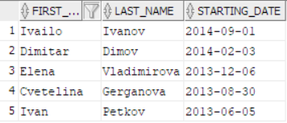  
Results from the execution:

1. Employee reference for position/department:

select * from (  
select First_Name, Last_Name, Department_Name, Position_Name  
from Employees_Information ei  
join Departments d  
ON d.ID_Department = ei.ID_Department  
join Positions p  
ON p.ID_Position = ei.ID_Position  
where d.Department_Name LIKE '%&Text%'  
and p.Position_Name LIKE '%&Text%'  
ORDER by d.Department_Name);

 Results from the execution:  
  
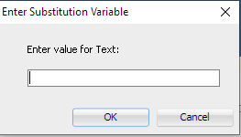  
  
We write **Production (CS)**, and after that one more window pop-out in which we write **Agent,** and the result is:

1. Reference for appointed employees for a period:

select ei.First_Name, ei.Last_Name, ei.Starting_Date  
from Employees_Information ei  
where ei.Starting_Date Like '%&Date%';

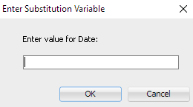Резултат от изпълнението:

When you write down year **2013** the result is:

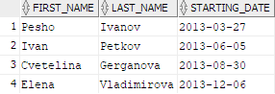

1. Report on the number of absences for each employee per year:

select ei.First_Name, ei.Last_Name, c.year, sum (a_p.count_absence) as CNT_Abs  
from Abscense_Presence a_p  
join Employees_Information ei  
on a_p.ID_Employee = ei.ID_Employee  
join ID_Absence a  
on a.count_absence = a_p.count_absence  
join Calendar c  
on c.ID_Calendar = a_p.ID_Calendargroup by ei.First_Name, ei.Last_Name, c.Year  
order by ei.First_Name, ei.Last_Name, c.Year desc;

Results from the execution:

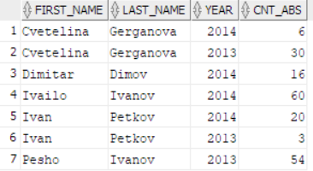

# Procedures

create or replace procedure ABSCENCE_TYPE_Ins

(

v_AbsType_N ABSCENCE_TYPE.TYPE_ABSCENCE_NAME%TYPE

)

AS

BEGIN

insert into ABSCENCE_TYPE(TYPE_ABSCENCE_NAME)

VALUES (v_AbsType_N);

END;

create or replace procedure ABSCENSE_PRESENCE_Ins

(

v_Pr_Cn ABSCENSE_PRESENCE.COUNT_PRESENCE%TYPE,

v_Abs_Cn ABSCENSE_PRESENCE.COUNT_ABSENCE%TYPE

)

AS

BEGIN

insert into ABSCENSE_PRESENCE(COUNT_PRESENCE, COUNT_ABSENCE)

VALUES (v_Pr_Cn, v_Abs_Cn);

END;

create or replace procedure CALENDAR_Ins

(

v_year CALENDAR.YEAR%TYPE,

v_MaxDays CALENDAR.MAXIMUM_DAYS_MONTH%TYPE

)

AS

BEGIN

insert into CALENDAR(YEAR, MAXIMUM_DAYS_MONTH)

VALUES (v_year, v_MaxDays);

END;

create or replace procedure DEPARTMENTS_INS

(

v_Dep_N DEPARTMENTS.DEPARTMENT_NAME%TYPE

)

AS

BEGIN

insert into DEPARTMENTS(DEPARTMENT_NAME)

VALUES (v_Dep_N);

END;

create or replace procedure EMPLOYEES_INFORMATION_INS

(

v_Emp_FN EMPLOYEES_INFORMATION.FIRST_NAME%TYPE,

v_Emp_LN EMPLOYEES_INFORMATION.LAST_NAME%TYPE,

v_Sal EMPLOYEES_INFORMATION.SALARY%TYPE,

v_St_Date EMPLOYEES_INFORMATION.STARTING_DATE%TYPE

)

AS

BEGIN

insert into EMPLOYEES_INFORMATION(FIRST_NAME, LAST_NAME, SALARY, STARTING_DATE)

VALUES (v_Emp_FN, v_Emp_LN, v_Sal, v_St_Date);

END;

create or replace procedure ID_ABSENCE_INS

(

v_Count_Abs ID_ABSENCE.COUNT_ABSENCE%TYPE

)

AS

BEGIN

insert into ID_ABSENCE(COUNT_ABSENCE)

VALUES (v_Count_Abs);

END;

create or replace procedure LANGUAGES_INS

(

v_Lang_N LANGUAGES.LANGUAGE_NAME%TYPE

)

AS

BEGIN

insert into LANGUAGES(LANGUAGE_NAME)

VALUES (v_Lang_N);

END;

create or replace procedure MONTHS_INS

(

v_Month_N MONTHS.MONTH_NAME%TYPE

)

AS

BEGIN

insert into MONTHS(MONTH_NAME)

VALUES (v_Month_N);

END;

create or replace procedure Positions_Ins

(

v_Pos_N positions.position_name%TYPE,

v_Pos_S positions.salary%TYPE

)

AS

BEGIN

insert into positions(Position_Name, Salary)

VALUES (v_Pos_N, v_Pos_S);

END;

create or replace procedure Positions_UPD

(

v_Pos_ID positions.id_position%TYPE,

v_Pos_N positions.position_name%TYPE,

v_Pos_S positions.salary%TYPE

)

AS

BEGIN

UPDATE Positions set

Position_Name = v_Pos_N,

Salary = v_Pos_S

WHERE ID_Position = v_Pos_ID;

END;

# Triggers

create or replace trigger ID_ABS_PRES_AUTO_TRG

before insert on ABSCENSE_PRESENCE

for each row

when (new.ID_ABSCENCE_PRESCENCE is null)

begin

:new.ID_ABSCENCE_PRESCENCE := SEQUENCE3.nextval;

end;

create or replace trigger ID_ABS_TYPE_AUTO_TRG

before insert on ABSCENCE_TYPE

for each row

when (new.ID_ABSCENSE_TYPE is null)

begin

:new.ID_ABSCENSE_TYPE := SEQUENCE2.nextval;

end;

create or replace trigger ID_CLD_AUTO_TRG

before insert on CALENDAR

for each row

when (new.ID_CALENDAR is null)

begin

:new.ID_CALENDAR := SEQUENCE4.nextval;

end;

create or replace trigger ID_DPT_AUTO_TRG

before insert on DEPARTMENTS

for each row

when (new.ID_DEPARTMENT is null)

begin

:new.ID_DEPARTMENT := SEQUENCE5.nextval;

end;

create or replace trigger ID_EI_AUTO_TRG

before insert on EMPLOYEES_INFORMATION

for each row

when (new.ID_EMPLOYEE is null)

begin

:new.ID_EMPLOYEE := SEQUENCE6.nextval;

end;

create or replace trigger ID_LANG_AUTO_TRG

before insert on LANGUAGES

for each row

when (new.ID_LANGUAGE is null)

begin

:new.ID_LANGUAGE := SEQUENCE8.nextval;

end;

create or replace trigger ID_Pos_AUTO_TRG

before insert on Positions

for each row

when (new.ID_Position is null)

begin

:new.ID_Position := SEQUENCE1.nextval;

end;

# Cursors

create or replace procedure LastFiveEmployees  
is  
begin  
DBMS_OUTPUT.PUT_LINE ('==============================');  
DBMS_OUTPUT.PUT_LINE ('|| Last Five Hired Employees||');  
DBMS_OUTPUT.PUT_LINE ('==============================');  
declare cursor C_LastFive is  
select * from (  
select First_Name, Last_Name, Starting_Date  
from Employees_Information  
order by Starting_Date desc)  
where rownum <=5;  
begin  
for C_Record in C_LastFive  
loop  
DBMS_OUTPUT.PUT_LINE (C_Record.First_Name || ' - ' || C_Record.Last_Name || ' ' || C_Record.Starting_Date);  
end loop;  
end;  
end;

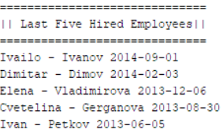

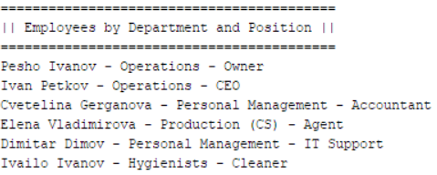create or replace procedure EmpDepPos  
is  
begin  
DBMS_OUTPUT.PUT_LINE ('==========================================');  
DBMS_OUTPUT.PUT_LINE ('|| Employees by Department and Position ||');  
DBMS_OUTPUT.PUT_LINE ('==========================================');  
declare cursor C_EmpDepPos is  
select * from (  
select First_Name, Last_Name, Department_Name, Position_Name  
from Employees_Information ei  
join Departments d  
ON d.ID_Department = ei.ID_Department  
join Positions p  
ON p.ID_Position = ei.ID_Position  
where d.Department_Name LIKE '%&Text%'  
and p.Position_Name LIKE '%&Text%'  
ORDER by d.Department_Name);  
begin  
for C_Record in C_EmpDepPos  
loop  
DBMS_OUTPUT.PUT_LINE (C_Record.First_Name || ' ' || C_Record.Last_Name || ' - ' || C_Record.Department_Name || ' - ' || C_Record.Position_Name);  
end loop;  
end;  
end;

create or replace procedure HiredEmpForPeriod  
is  
begin  
DBMS_OUTPUT.PUT_LINE ('==================================');   
DBMS_OUTPUT.PUT_LINE ('|| Hired Employees for a Period ||');   
DBMS_OUTPUT.PUT_LINE ('==================================');   
declare cursor C_HiredEmp is   
select ei.First_Name, ei.Last_Name, ei.Starting_Date  
from Employees_Information ei  
where ei.Starting_Date Like '%&Date%';  
begin  
for C_Record in C_HiredEmp  
loop  
DBMS_OUTPUT.PUT_LINE (C_Record.First_Name || ' ' || C_Record.Last_Name || ' - ' || C_Record.Starting_Date);  
end loop;  
end;  
end;

begin  
HiredEmpForPeriod;  
end;

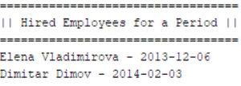

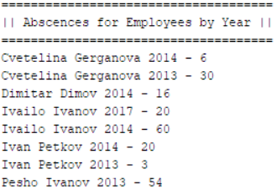create or replace procedure AbsCountEmpYear  
is  
begin  
DBMS_OUTPUT.PUT_LINE ('=====================================');  
DBMS_OUTPUT.PUT_LINE ('|| Abscences for Employees by Year ||');  
DBMS_OUTPUT.PUT_LINE ('=====================================');  
declare cursor C_AbsEmp is  
select ei.First_Name, ei.Last_Name, c.year, sum (a_p.COUNT_ABSENCE) CNT_Abs  
from ABSCENSE_PRESENCE a_p  
join EMPLOYEES_INFORMATION ei  
on a_p.ID_Employee = ei.ID_Employee  
join ID_Absence a  
on a.COUNT_ABSENCE = a_p.COUNT_ABSENCE  
join Calendar c  
on c.ID_Calendar = a_p.ID_Calendar  
group by ei.First_Name, ei.Last_Name, c.year  
order by ei.First_Name, ei.Last_Name, c.year desc;  
begin  
for C_Record in C_AbsEmp  
loop  
DBMS_OUTPUT.PUT_LINE (C_Record.First_Name || ' ' || C_Record.Last_Name || ' ' || C_Record.Year || ' - ' || C_Record.CNT_Abs);  
end loop;  
end;  
end;